KHELO INDIA PARA GAMES 2023
About

KIPG 2023 is the latest addition to the government of India’s Khelo India initiative, which also includes the Khelo India Youth Games, Khelo India University Games and Khelo India Winter Games.
Around 1,400 top para athletes from around the country are competing at the Khelo India Para Games 2023, which began in New Delhi on Sunday (December 10). The inaugural KIPG will go on till December 17.
So far, Haryana top the KIPG 2023 medal tally with 23 gold, 29 silver and 10 bronze medals.
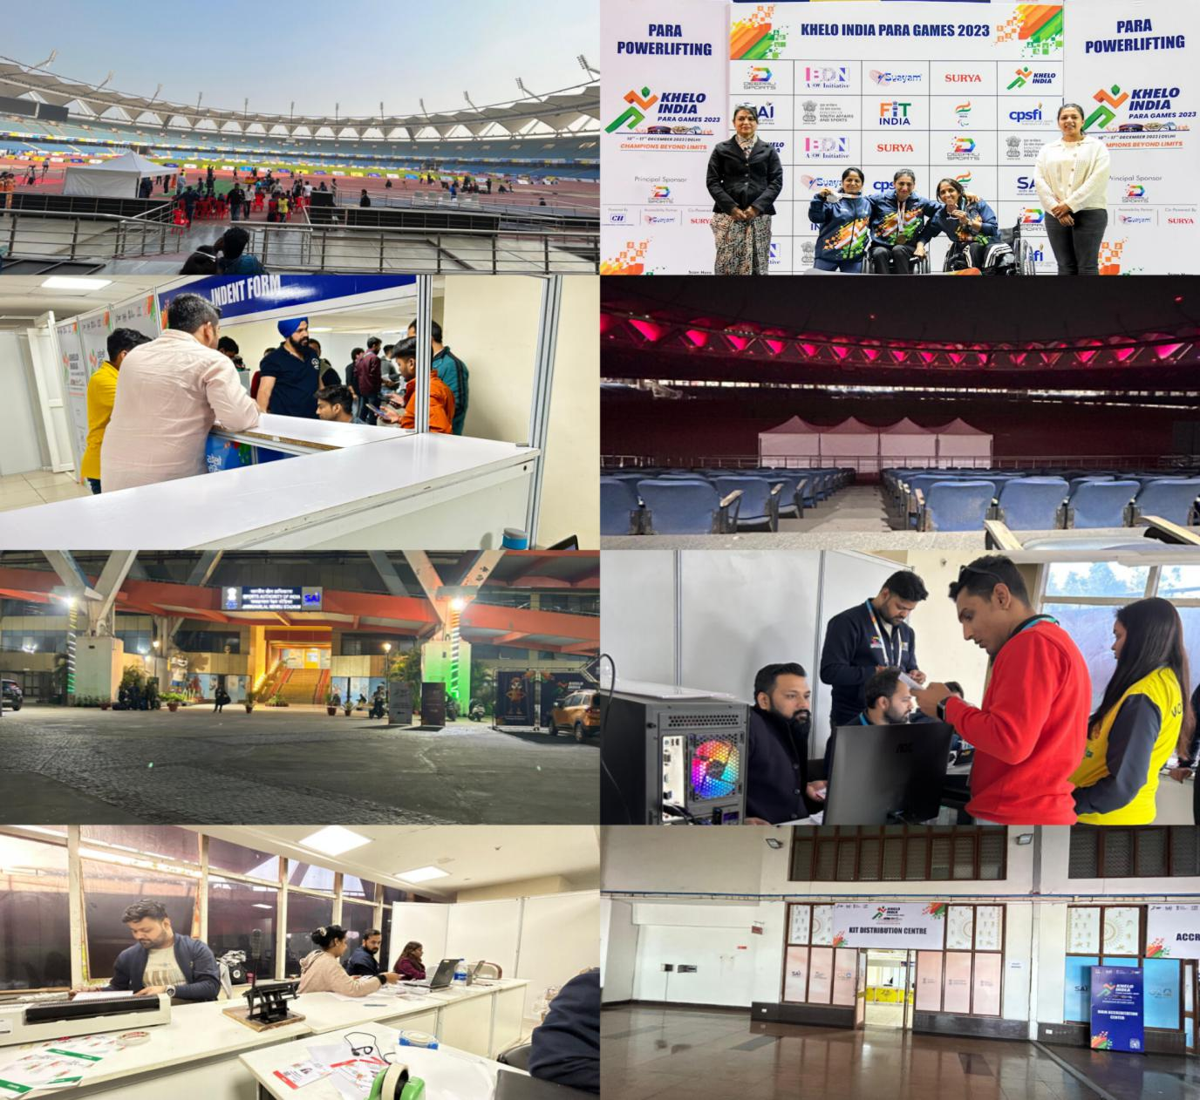

ACCREDITATION

INTRODUCTION
Accreditation is the process of registering, producing, distributing, and validating the Khelo India Para Games accreditation card that permits the holder access rights and other privileges at the Khelo India University Games. The organizing committee of the Khelo India Para Games 2023 issued accreditation cards to every individual who was present at the venue for the Khelo India Para Games.
The purpose of the accreditation card was to identify people and their roles for the Khelo India Para Games and allow them necessary access to perform their roles. Accreditation Cards limited the access of the holder to areas specified on the card and prevented unauthorized personnel from entering secure zones.
Components of Functional Area

Accreditation Matrix

The accreditation matrix was a complete grid of the various categories of cards to be created for the different sets of people visiting the Khelo India Para Games 2023 venue. The matrix clearly defined the zones that each person was permitted to access. The matrix created was accompanied by the access zones. This helped each person to understand the designated zones he or she has access to.

- Head/Category (With Colour combination of each Head/category):
S.NO. | HEADS | Colour Coding
1 | VVIP | Gold
2 | VIP | Gold
3 | Chef-De- Mission | Brown
4 | COMPETITION MANAGER | Silver
5 | Broadcast | Silver
6 | SPONSORS AND PARTNERS (SPS) | Silver
7 | ATHLETE | Green
8 | TEAM OFFICIALS | Green
9 | TECHNICAL OFFICIALS | Blue
10 | MEDIA PARTNER | Yellow
11 | MEDIA | Yellow
12 | VOLUNTEERS | White
13 | LOCAL ORGANIZING COMMITTEE (LOC) | Red
14 | EVENT MANAGEMENT AGENCY (EMA) | Orange
15 | SERVICE PROVIDERS (SVP) | Purple
16 | Medical | Pink
17 | Security Black

Access Zone:
The accreditation zones were decided for every person entering the venue. These zones determined the access a person had to the venue depending on the category he or she fell under. The zoning matrix was prepared to keep in mind the people and the organizations they represented. The zoning matrix comprised symbols and color codes marking the various areas across the venue (Annexures 3, 4)
The zoning took place at each venue by mapping out exactly what signage would go where. This helped in the movement of people in an organized manner.

ZONE | DEDICATED AREAS
AVA | ALL VENUE ACCESS (EXCEPT FOP)
FOP | FIELD OF PLAY
ZONE 1 | ATHLETE PREPRATION AREA
ZONE 2 | TECHNICAL OFFICIALS AREA
ZONE 3 | PRESS AREA, MEDIA TRIBUNE/LOUNGE, BROADCASTING AREA
ZONE 4 | OPERATION AREA
ZONE 5 | VIP/ GAMES FAMILY
T1 | DEDICATED CAR WITH DRIVER
T2 | ON CALL FLEET
T3 | ATHLETE SHUTTLE BUS
T4 | TECHNICAL OFFICIALS, MEDIA SHUTTLE BUS
 | VVIP/VIP LOUNGE
 | Dinning as per Category

Accreditation Cards

The accreditation cards created were according to the various categories decided in the matrix. These cards were categorized via different colors for different categories. The accreditation cards created for the Khelo India University Games 2022 included information such as:
Name of the Person:
Category:
Responsible Organization:
Designation:
Access:

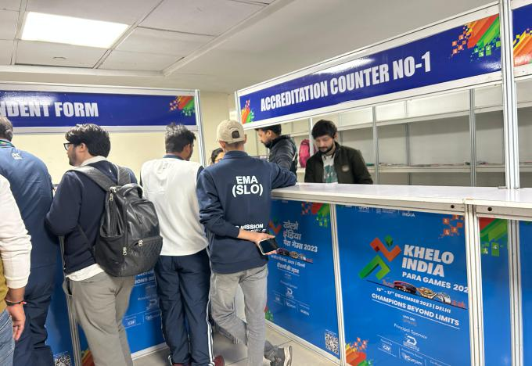
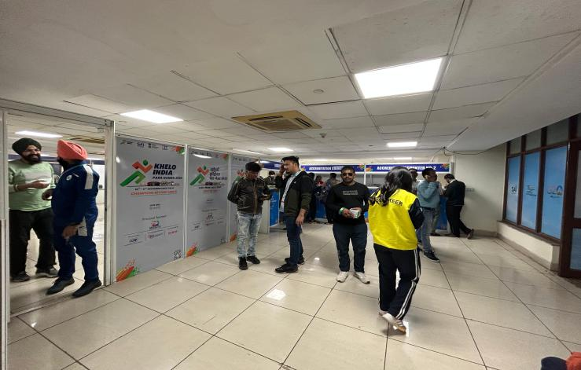

C. Lanyards

The lanyard for the Khelo India Para Games 2023 was of a single color (white) for all
categories.

Standard Operating Procedure (SOP)

The standard operating procedure for accreditation was as below:

Accreditation List
The FA head received the list of people for whom accreditations needed to be prepared. This list comprised people across the following categories:

Sr. No | Head | To be Received From
1. | Athletes | CDM
2. | Team Official | CDM
3. | Technical Officials | GTCC
4. | Volunteers/ SSV | Volunteer Operations
5. | VIPs & VVIPSs | Protocol Team (State & Central)
6. | LOC | TSC Committee / SAI
7. | Workforce | EMA / Host State
8. | Media | Media Team
9. | Medical | Medical Team
10. | Broadcasting | Broadcasting Team

No. of Accreditation Passes to be Printed

- A designated number of accreditations were pre-printed based on lists shared by the various verticals. This number was decided in advance and was mentioned in the BOQ.
- The BOQ also mentioned the number of accreditations to be printed as daily passes and were supposed to be kept ready for personnel attending the games

Accreditation Segregation Process

The accreditations once printed were segregated before being distributed. Each vertical had a separate segregation process which enabled the team to distribute the accreditations in a smooth manner.

- Accreditation going to players and support staff was segregated in the following sequence.
  - State wise
  - Sports wise

- Players
- Supporting Staff

- Accreditation going to technical officials
  - Sports-wise segregation
- Accreditation going to volunteers
  - It was segregated either FA-wise or coordinator wise
- Accreditation going to media agencies
  - It was segregated agency wise

- Accreditation going to the event management agency
  - It was segregated FA-wise.

Accreditation Distribution
The accreditations for the following heads were distributed as below:

Sr. No | Head | Distributed To
1. | Athletes | CDM
2. | Team Official | CDM
3. | Technical Official | GTCC
4. | Volunteers | Volunteer Operations
5. | VIPs & VVIPSs | Protocol Team (State & Central)
6. | LOC | TSC Committee / SAI
7. | Workforce | EMA / Host State
8. | Media | Media Team
9. | Medical | Medical Team
10. | Broadcast | Broadcasting Team

Players & Support Staff
For the accreditations to be distributed to the players, below was the process that was followed once we got the confirmation on the time slots for each of the CDMs:

- The CDM arrived at the accreditation room
- The CDM showed her proof of identity
- He or she proceeded to the concerned person from the accreditation team for collection of the accreditations for his or her state.
- Accreditations were segregated and kept ready for each state. The CDM was handed the designated accreditations along with three documents (2 copies) -
  - Player list
  - Instruction Sheet
  - Declaration confirming the receipt of the accreditations
- The CDM signed off each document. The CDM kept one copy of the document and the second copy was kept by the accreditation team.
- The CDM then proceeded to the sports kit distribution area to collect the sports kit for his or her state.

- Technical Officials

The process we followed for the distribution of accreditations to the technical officials was as follows:

- The respective sports representatives arrived at the accreditation room
- The sports representatives had to produce their proof of identity
- They then proceeded to the concerned person from the accreditation team to collect the accreditations for their sport.
- Accreditations were segregated and kept ready for each sport. They were handed over the designated accreditations along with documents (2 copies) -
  - Officials List
  - Instruction Sheet
  - Declaration confirming the receipt of the accreditations
- Then they had to sign off each document. They kept one copy of the document and the second copy was kept by the accreditation team.

- Volunteers

For the accreditations to be distributed to the respective sports heads, below is the process we followed
- The respective coordinators arrived at the accreditation room
- The coordinator had to show us their proof of identity
- They then proceeded to the concerned person from the accreditation team to collect the accreditations for their group of volunteers.
- Accreditations were segregated and kept ready for each coordinator. They were handed over the designated accreditations along with documents (2 copies)-
  - Volunteers List
  - Instruction Sheet
  - Declaration confirming the receipt of the accreditations
- They then signed each document. They kept one copy of the document and the second copy was kept by the accreditation team.
They then proceeded to the sports kit distribution area to collect the sports kits for their group of volunteers

- Workforce

The process for the distribution of accreditations to the Event Management Agency was:

- The respective EMA heads arrived at the accreditation room
- They showed their proof of identity
- They then proceeded to the concerned person from the accreditation team for collection of the accreditations for his or her team.
- Accreditations were segregated and kept ready for each EMA. They were handed over the designated accreditations along with:
  - Workforce List
  - Declaration confirming the receipt of the Accreditations
- The FA head had to sign off each document. They kept one copy of the document and the second copy was kept by the accreditation team.

- Media

The process for the distribution of accreditations to the Media Agency was:

- The representative arrived at the accreditation room.
- The representative showed us his/her proof of identity.
- He/she then proceeded to the concerned person from the accreditation team for the collection of the accreditations for his or her group of volunteers.
- Accreditations were segregated and kept ready for each media agency. They were handed over the designated accreditations along with two documents (2 copies)-

  - Media Officials List
  - Declaration confirming the receipt of the Accreditations
The representative had to sign off on each document. They kept one copy of the document and the second copy was kept by the accreditation team.

CITY WISE SAI MANPOWER ATTENDANCE
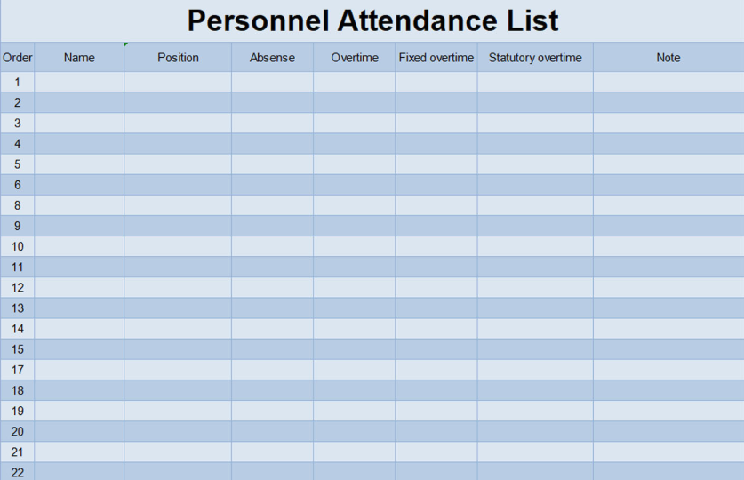
SIGN OFF DOCUMENT

Khelo India Para Games 2023 – Accreditation Cards Handover

DATE:
Dear _______________,

This is to confirm that the following Khelo India Para Games 2023 Accreditation Cards and Lanyards (as per the attached card collection list) have been counted and received.
Company / Contingent | Quantity of cards | Received cards

Kindly acknowledge handover of above-mentioned card

Authorised: Distributed: Received:

______________ ________________ _________________

Name: Name: Name:

Sign: Sign: Sign:
Work Report

ACCREDITATION REPORT – KHELO INDIA PARA GAMES 2023,

Scope of Work
Data entry: Close to 2000 offline forms were entered into the GMS portal for data to be recorded on the system and eventually the accreditations were made ready.

Zoning: Accreditation zoning was planned and implemented across the various sporting venues in Lucknow, Varanasi, Gorakhpur, GB Nagar, and Delhi. The Zones were needed in accordance with the Accreditation matrix prepared for the purpose of ensuring that access to places within the venue was as required.

Accreditation Printing: Accreditations were printed on high-quality laser print. The technical specifications of the accreditations and the lanyards were as follows:
• Material: PVC
• Thickness: 30mm
• Size: A6 (88 x 140 mm)
• Lanyard fabric: Satin
• Hook: Metal C Double hook
• Printed lanyard: Logo and event details

Daily Passes: Daily passes were printed on a need basis. The specifications of the pouch for the day passes were:
• Material: PET + EVA
• Thickness: 225 microns
• Size: For A6 paper passes
• Material of the Day Pass: 120 GSM

Timelines: Time-bound printing, checking, segregating, and distribution of the accreditations.

QR scanning:
Functioning of QR Scanning:
• QR codes were linked to individual forms and were printed accordingly.
• Accreditation staff was deployed in each catering venue along with their respective categories i.e. VIP dining/Dining as per the category.
• Deployment timings were as per Breakfast, Lunch, High Tea & Dinner
• QR codes could only be scanned by the official KIYG 2022 app and all the manpower was trained to use that adequately.
• Daily reports were generated at the end of the day and shared with the concerned authority’s city/venue-wise

ACCREDITATION

Accreditaion Process
The accredidation process consisted of the following steps:
A. Creation of an Accreditation matrix
B. Venue Zoning
C. Acquisition of Data for Accreditation Purposes
D. Update information in a trusted format
E. Accreditation printing
F. Distribution of Accreditation

Accreditation Matrix

The KIUG 2022 Accreditation Matrix was created considering the various personnel who were likely to visit the venue, from VVIPs to service providers. Each group of people received a color code that reflected in their certification, making it easier to identify categories of people. Once the matrix was created, it was released by DDG for further use in creating certification cards. Over 1600 volunteers were dispatched to KUYG 2023, and it was essential to create a separate grid for volunteers according to different functional areas assigned for certification purposes. Each volunteer certification had access according to their assigned functional area. KIUG 2023 included 5 state venues and 21 sports events at different venues in Lucknow, Varanasi, Gorakhpur, GB Nagar, and Delhi. It was essential to create a separate event code for every sporting area to define which sporting venues each person could access. A three-digit code was created for each stadium, which was identified by the accreditation system and then added to the accreditation.
Below are the following for reference:
• Accreditation Matrix
• Volunteer Codes
• Venue Codes

S.  No | Category |  | Designation/Role | Venue |  | VVIP/ VIP | Dinning as per category | Transport
S.  No |  |  | Designation/Role | Sport | Zone | Dinni ng | Dinning as per category | Transport
1 | VVIP | VVIP | MoYAS | AVA | 1,2,3,4,5 | Yes |  | T1
1 | VVIP | VVIP | MoS,YAS | AVA | 1,2,3,4,5 | Yes |  | T1
1 | VVIP | VVIP | Secretary Sports | AVA | 1,2,3,4,5 | Yes |  | T1
1 | VVIP | VVIP | Joint Secretary-MYAS | AVA | 1,2,3,4,5 | Yes |  | T1
1 | VVIP | VVIP | Executive Director SAI | AVA | 1,2,3,4,5 | Yes |  | T1
1 | VVIP | VVIP | Deputy Secretary-  MYAS/SAI | AVA | 1,2,3,4,5 | Yes |  | T1
1 | VVIP | VVIP | Director MYAS/SAI | AVA | 1,2,3,4,5 | Yes |  | T1
1 | VVIP | VVIP | HPC Members | AVA | 1,2,3,4,5 | Yes |  | T1
1 | VVIP | VVIP | OC/EC Members | AVA | 1,2,3,4,5 | Yes |  | T1
1 | VVIP | VVIP | President (IOA) | AVA | 1,2,3,4,5 | Yes |  | T1
1 | VVIP | VVIP | Treasurer (IOA) | AVA | 1,2,3,4,5 | Yes |  | T1
1 | VVIP | VVIP | Sr. Vice-President (IOA) | AVA | 1,2,3,4,5 | Yes |  | T1
1 | VVIP | VVIP | Vice-President (IOA) | AVA | 1,2,3,4,5 | Yes |  | T1
1 | VVIP | VVIP | Joint Secretary (IOA) | AVA | 1,2,3,4,5 | Yes |  | T1
1 | VVIP | VVIP | President (PCI) | AVA | 1,2,3,4,6 | Yes |  | T1
1 | VVIP | VVIP | General Secretary (PCI) | AVA | 1,2,3,4,7 | Yes |  | T1
1 | VVIP | VVIP | President (CPSFI) | AVA | 1,2,3,4,8 | Yes |  | T1
1 | VVIP | VVIP | General Secretary (CPSFI) | AVA | 1,2,3,4,9 | Yes |  | T1
1 | VVIP | VVIP | President (NSF) | AVA | 1,2,3,4,5 | Yes |  | T1
1 | VVIP | VVIP | Secretary General (NSF) | AVA | 1,2,3,4,5 | Yes |  | T1
1 | VVIP | VVIP | Guest | AVA | 1,2,3,4,5 | Yes |  | T1
1 | VIP | VIP | Guest | AVA | 1,2,3,4,5 | Yes |  | T1
1 | VIP | VIP | Executive Member (IOA) | AVA | 1,2,3,4,5 | Yes |  | T1
1 | VIP | VIP | Under Secretary, MYAS | AVA | 1,2,3,4,5 | Yes |  | T2
1 | VIP | VIP | Section Officer | AVA | 1,2,3,4,5 | Yes |  | T2
1 | VIP | VIP | PCI Officials | AVA | 1,2,3,4,5 | Yes |  | T2
1 | VIP | VIP | CPSFI Officials | AVA | 1,2,3,4,5 | Yes |  | T2
1 | VIP | VIP | Member/Representative of PCI, CPSFI & NSF | AVA | 1,2,3,4 | Yes |  | T1
2 | Chef-De-  Mission | CDM | Chef-De- Mission | AVA | 1,2,3,4,5 | Yes |  | T1
3 | Competition Manager | Competition Manager | Competition Manager | AVA | FOP,1,2,3,4,5 | Yes |  | T1
4 | Broadcast | Broadcast | Media Partner Executive & Sr, Officials | AVA | 1,2,3,4,5 | Yes |  | T2
5 | Sponsors  and Partners | SPs | Executive of Official  Sponsor | AVA | 4,5 | Yes |  | T1
 |  |  | Executive of Program  partner | AVA | 4,5 | Yes |  | T1
 |  |  | Executive of major  Supplier | AVA | 4,5 | Yes |  | T1
6 | Athlete | Athlete | Athletes | SPT | FOP,1,3,4 |  | Athlete | T3
7 | Team Officials | Team Officials | University Sports  Manager | SPT | FOP,1,3,4 |  | Athlete | T3
7 | Team Officials | Team Officials | Coach | AVA | FOP,1,3,4 |  | Athlete | T3
7 | Team Officials | Team Officials | Medical professionals | AVA | FOP,1,3,4 |  | Athlete | T3
7 | Team Officials | Team Officials | Extra Officials | SPT | 1,3 |  | Athlete | T3
7 | Team Officials | Team Officials | Escorts | SPT | FOP,1,3,4 |  | Athlete | T3
8 | Technical Officials | Technical Officials | NTO | SPT | FOP,2,4 | Yes |  | T4
8 | Technical Officials | Technical Officials | ITO | SPT | FOP,2,4 | Yes |  | T4
8 | Technical Officials | Technical Officials | Referee | SPT | FOP,2,4 | Yes |  | T4
8 | Technical Officials | Technical Officials | Jury member | SPT | FOP,2,4 | Yes |  | T4
8 | Technical Officials | Technical Officials | Classifiers | SPT | FOP,2,4 | Yes |  | T4
8 | Technical Officials | Technical Officials | Timer/Scorer | SPT | FOP,2,4 | Yes |  | T4
9 | Broadcast | Host Broadcast | Host Broadcaster | AVA | FOP,3,4
10 | Media | Media | Journalist | AVA | 3,4,5 |  | LOC
10 | Media | Media | Photographer | AVA | FOP,3,4,5 |  | LOC
11 | Volunteers | Volunteers | Volunteer | Role Specific |  |  | LOC
12 | LOC | LOC-KIPG | Director General SAI | AVA | 1,2,3,4,5 |  | LOC | T1
12 | LOC | LOC-KIPG | Secretary SAI | AVA | 1,2,3,4,5 |  | LOC | T1
12 | LOC | LOC-KIPG | Deputy Director General | AVA | 1,2,3,4,5 |  | LOC | T1
12 | LOC | LOC-KIPG | FA Heads | AVA | 1,2,3,4,5 |  | LOC | T1
12 | LOC | LOC-KIPG | FA Members | AVA | 1,2,3,4,5 |  | LOC | T2
12 | LOC | LOC-KIPG | DD/AD-SAI | AVA | 1,2,3,4,5 |  | LOC | T2
12 | LOC | LOC-KIPG | FA Head-SAI | AVA | 1,2,3,4,5 |  | LOC | T1
12 | LOC | LOC-KIPG | FA-Member-SAI | AVA | 1,2,3,4,5 |  | LOC | T2
12 | LOC | LOC-KIPG | Sr. Consultant/Jr. Consultant/Young Professional - SAI | AVA | 1,2,3,4,5 |  | LOC | T2
13 | Event Managemen t Agency | EMA | EMA , Sr. Management | AVA | 1,2,3,4,5
13 | Event Managemen t Agency | EMA | Accommodation | AVA | 1,2,3,4
13 | Event Managemen t Agency | EMA | Accreditation | AVA | 1,2,3,4
13 | Event Managemen t Agency | EMA | Ceremonies | AVA | FOP,1,2,3,4,5
13 | Event Managemen t Agency | EMA | Communication | AVA | 1,2,3,4,5
13 | Event Managemen t Agency | EMA | Technology | AVA | FOP,1,2,3,4,5
13 | Event Managemen t Agency | EMA | Venue Development &  Overlays | AVA | FOP,1,2,3,4,5
13 | Event Managemen t Agency | EMA | Transport | AVA | 1,2,3,4
14 | Service Providers | Service Providers | Accommodation | AVA | 4
14 | Service Providers | Service Providers | Ceremonies | AVA | FOP,4
14 | Service Providers | Service Providers | Communication | AVA | 3,4
 |  |  | Medical & Dope Control | AVA | FOP,1,2,3,4,5
 |  |  | Technology | AVA | 1,2,3,4,5
 |  |  | Venue Development &  Overlays | AVA | FOP,1,2,3,4,5
 |  |  | Transport | AVA | 4
15 | Medical | Medical | Medical professionals | AVA | FOP,1,2,3,4,5 |  | LOC
16 | Security | Security | Security | Role Specific |  |  | LOC
      - Accreditation Matrix

      - Volunteer Access:
Volunteer Category | Venue
Volunteer Category | Sport | Zone | LOC Dining
Transportation | All | 4 | Yes
Accommodation | All | 4 | Yes
Protocol | All | FOP,4,5 | Yes
Sports Presentation | All | FOP,4 | Yes
Medical and Anti Doping | All | FOP1,2,3,4,5 | Yes
Spectator Management | All | 4 | Yes
Catering | All | 1,2,3,4,5 | Yes
Marketing, Branding & Activation | All | 4 | Yes
Accreditation | All | 4 | Yes
Volunteer Management | All | FOP,1,2,3,4,5 | Yes
Sports Facility | All | FOP,1,4 | Yes
Sports Kit | All | 4 | Yes
Gardening | All | 4 | Yes
Helpdesk | All | 4 | Yes
Venue Operations | All | FOP,1,2,3,4,5 | Yes
Hardware Support | All | FOP,1,2,3,4,5 | Yes
Venue Branding | All | 1,2,3,4,5 | Yes
Broadcast Partner and Coordination | All | FOP,3,4 | Yes
Media Volunteers | All | 3,4 | Yes
State Coordination & GTCC | All | 1,2,4 | Yes
SSV | SPT | FOP,1,4 | Yes
Security | All | Role Specific | Yes

      - Venue Codes :

KHELO INDIA PARA GAMES 2023 SPORTS, VENUE AND CODES

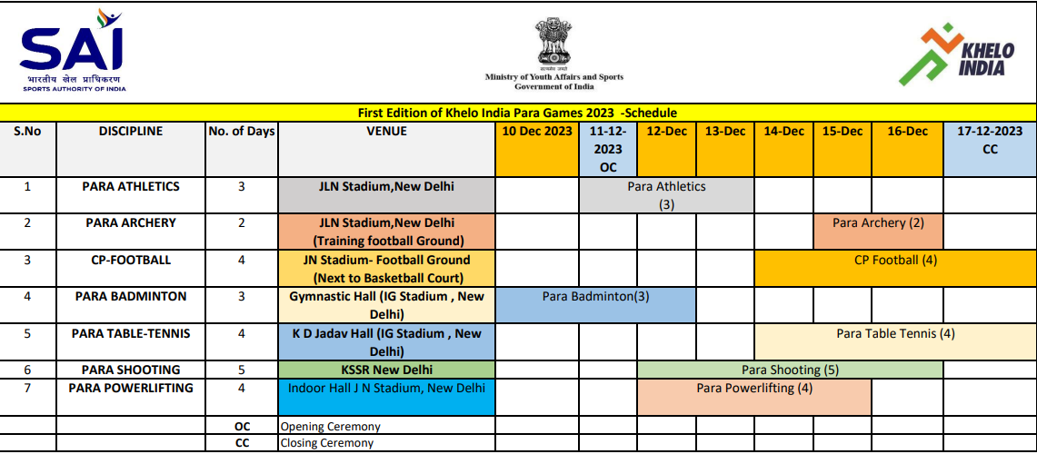

ZONE | DEDICATED AREAS
AVA | ALL VENUE ACCESS (EXCEPT FOP)
FOP | FIELD OF PLAY
ZONE 1 | ATHLETE PREPARATION AREA
ZONE 2 | TECHNICAL OFFICIALS AREA
ZONE 3 | PRESS AREA, MEDIA TRIBUNE/LOUNGE, BROADCASTING AREA
ZONE 4 | OPERATION AREA
ZONE 5 | VIP/ GAMES FAMILY
T1 | DEDICATED VEHICLE WITH CAR DRIVER
T2 | ON CALL FLEET
T3 | ATHLETE SHUTTLE BUS
T4 | TECHNICAL OFFICIALS, MEDIA SHUTTLE BUS
 | VVIP/VIP LOUNGE
 | DINING AS PER CATEGORY

Receiving data for accreditation

At KIUG 2023, it was compulsory for everyone involved with the game, including players, officials, staff, media, and volunteers, to register on the KIUG 2023 - GMS portal. The portal required all information to be uploaded along with a photo of the person in question. Data uploaded for players, team officials, and technical officials were nominated by the state and his NSF before the data was printed.
The GMS portal remained open during the event due to wild card entries and changes in support
GMS PORTAL – ATHELETE DASHBOARD

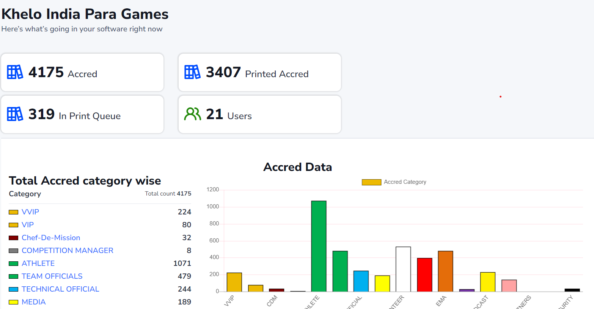
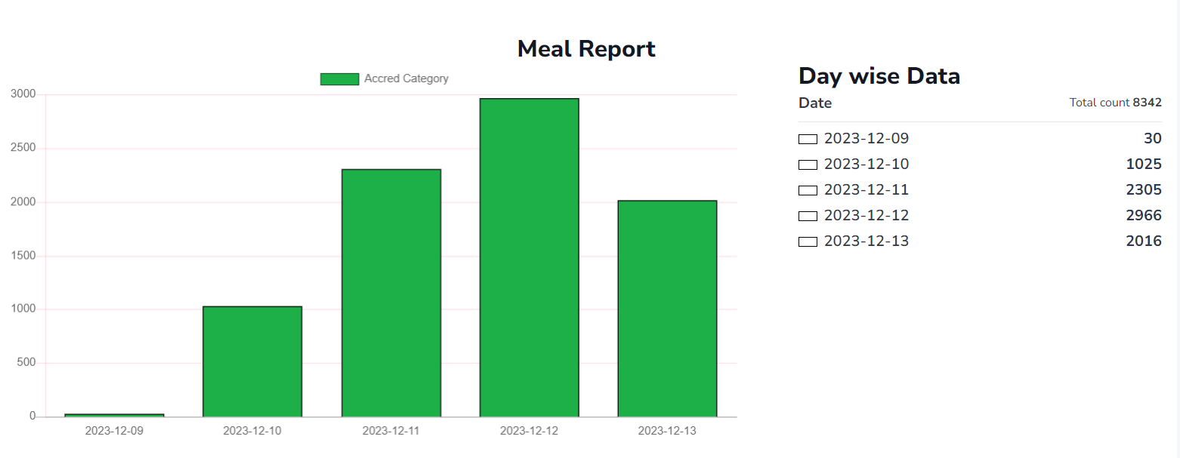

Accreditation Ready Format

The accreditation data uploaded to the portal contained a lot of information that was not needed to print the accreditation. Therefore, this data should be updated to a certification-ready format that only contains information used for accreditation. This standard format was used to print all the required accreditation at KIUG 2022. Below is the format of the data sent to the printing team.

Below is the process flow of accreditation data uploaded on the portal, shortlisted, and updated to become accreditation ready.
• Accreditation team received Accred Ready format data by mail from various stakeholders in Khelo India GMS Portal.
• Accreditation team uploaded the data on their portal.
• Approved data was sent for printing at various venues.

Accreditation Printing

Accreditations for the KIYG 2023 were printed for personnel across various verticals:
• Athletes
• Support Staff
• Protocol
• Volunteers
• Media
• EMA
• Service Providers
• Local Organizing Committee
• Technical Officials
• Broadcast
• Talent Scout
• Sponsor

Distribution of the Accreditations

Accreditations prepared for personnel across different verticals were segregated (Athletes & Team Officials) and then further distributed to the respective verticals. Below is the process of the accreditation distribution that was undertaken for the KIUG 2022.

Accreditation & Lanyard Samples (Image)

Below are the samples of the various categories of accreditations/lanyard created for the KIUG 2023:

